Generic EVS Design Specification
for
Gazelle
Version 0.3 draft
Prepared by Robert Snelick, Rick Busbridge, Andrew McCaffrey

2008.09.26
Table of Contents
1. Introduction 1
2. Interfaces 1
2.1 validate 2
2.1.1 Return Value 2
2.1.2 Parameters 2
2.2 getServiceStatus 2
2.3 getResults 3
2.3.1 Return Value 4
2.3.2 Parameters 4
2.4 deleteResults 4
2.4.1 Return Value 4
2.4.2 Parameters 4
2.5 loadResource 4
2.5.1 Return Value 5
2.5.2 Parameters 5
3. References 5

Revision History
Name | Date | Reason For Changes | Version
Robert Snelick | 2008.09.26 | Initial Draft; Adapted from the original design document from Rick Busbridge | 0.1
Robert Snelick | 2008.10.22 | Revised draft as the result of meetings and review. | 0.2
Robert Snelick | 2008.10.29 | Update | 0.3

Introduction
This document describes the design specification of the generic External Validation Service (EVS) for Gazelle. The interface described is for a Web Service environment. The specification presented here is not intended for direct implementation; companion documents for a given protocol describe those details. This document presents the generic view and interfaces that a specific protocol EVS could implement. EVS specifications have been developed for HL7 Version 2 [1], DICOM [2], and the Clinical Document Architecture (CDA) [3] standards.

An EVS is a service that validates a test object against a test specification. The results are reported to the client as an XML document. An EVS can be used by an independent client or be a component within a testing framework such as Gazelle. A registry, repository, or database may be associated with an EVS.

A key design goal for EVS implementations is to be state-less. Although this has largely been achieved for the key validate method, part of the service must maintain state. Figure 1 gives possible design models and depicts interactions with other test framework components.

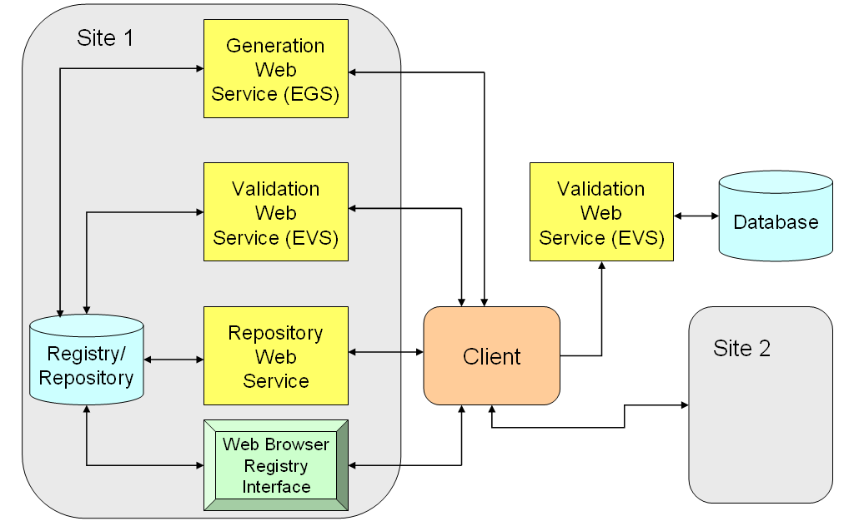
Figure 1. EVS Implementation Models

Interfaces
An EVS can implement the following methods; validate(), getServiceStatus(), getResults(), deleteResults() and loadResource(). The validate() method is required. Implementations may or may not support persistent or extended results.

validate
The validate() method is used to validate a test object instance to a specification and/or data content assertions.

String xmlResults = validate (type testObject,String testSpecification, String xmlConfig, String xmlValidationContext);

Return Value
xmlResults – common XML document for reporting the results of the validation. The results report specification contains a header section that is common to all results reporting and a detailed section that is specific to the validation protocol. See the “Validation Results Reporting for Gazelle [4]” for details.

xmlResults may optionally contain an identifier to an extended report. This is dependent on the validation protocol.

Parameters
testObject – the object that is being validated. There is no type specified at this level of granularity; the type is dependent on the validation protocol. Examples include an HL7 V2 message or a CDA document. This parameter is required.

testSpecification – test material used in the validation. Examples include a standard, profile, schema, and template. The testSpecification may refer to the actual test specification or it may be a reference to the test specification. This is dependent on the validation protocol web service. This parameter is optional.

xmlConfig – describes configuration information that can be used by the validation service. The xmlConfig design is specific to the validation protocol. This parameter is optional.

xmlValidationContext – describes specific data content assertions associated with a specific testObject. The validation context information can be used in scenario base testing. This parameter is optional.

Note 1: some parameters are optional at the generic level; they may be required or not supported at the specific level validation service specification.

Note 2: although some parameters are listed optional at the generic level and may be not supported at the specific level validation service specification, placeholders for the parameters are required. A value of “null” is used for not supported parameters. In other words, the signature of the method call will contain all four parameters specified above even though they may not be used at the protocol specific level.

getServiceStatus
The getServiceStatus() method returns a list of the specifications and resources available to the validation service. Note that if the service is not operational, the call will not return. Therefore the getServiceStatus() invocation can be used to query the service for the list of supported validation specifications and other resources or to ping the operational status of the service. The supported specifications and available resources are returned in the xmlResourceList document.

String xmlResourceList = getServiceStatus ();

An XML string is returned (xmlResourceList) that provides descriptive information about the available validation resources. The xmlResourceList will provide this information for all the available validation resources provided by the service. This may include the validation specifications or associated validation resources. The following attributes describe a particular resource.

resourceID: This identifier references the validation resource. This is protocol specific. For example, in HL7 V2 it is an OID. The resourceID can be used in the validate() method to indicate the specification.

name: A descriptive name of the resource.

version: The version of the resource.

organization: The organization that created, provided, or owns the resource.

date: The date the resource was created.

description: A detailed description of the resource.

The protocol specific services may add additional attributes. For example, HL7 V2 adds the HL7 version of the profile.

getResults
The validation method is a stateless call. However, validation results may be stored on the server. The getResults() method is used to retrieve any validation results that are stored by the validation service. There are two types of persistent results:

extended results: Extended results contain additional validation results beyond what is reported in the xmlResults report. The results are stored on the server and can be retrieved by the client. The extended results are referenced by the extended results identifier (extendedResultsID). This identifier is in the xmlResults report. The identifier can be specified in the xmlConfig or assigned by the web service (if not specified in xmlConfig). Some validation services may need extended results (e.g., DICOM) while others will not (e.g., CDA). This is determined by the validation specific service.

stored results – Stored results are persistent result reports that are maintained by the validation server and can be retrieved by the client. The reports are exact copies of the xmlResults document returned from the validate() method. The stored results report is referenced by the results identifier (resultsID) and is specified in the xmlResults report. The identifier can be set in the xmlConfig or assigned by the web service (if not specified in xmlConfig). Some validation services may support stored results while others will not. This is determined by the validation specific service provider. For example, one HL7 V2 provider may store results while others may not.

String xmlPersistentResults = getResults (String resultsID);

Return Value
xmlPersistentResults – an XML document containing persistent results. The results are from a previous invocation of a validate() method. The results may be for extended results or for stored results. The format of the extended results document is specific to the validation service. The format of the stored results is the same as the xmlResults report for the specific validation service.

Parameters
resultsID – is an identifier referencing the persistent results report of a validation instance (xmlResults.resultsID). The resultsID can reference extended results or stored results. The format of the resultsID is specific to the validation service.

deleteResults
The deleteResults() method is used to remove a persistent results report from a service. This can include extended results or stored copies of the xmlResults documents.

boolean flag = deleteResults (String resultsID);

Return Value
returns true if the document has been successfully deleted from the service; false otherwise.

Parameters
resultsID – is an identifier referencing the persistent results report of a validation instance (xmlResults.resultsID). The resultsID can reference extended results or stored results. The format of the resultsID is specific to the validation service.

loadResource
The loadResource() method is used to load a resource that can be used in a subsequence validate() invocation. The resource is typically a specification, for example, a profile for HL7 V2. The length of time the resource is available for use in validation is determined by the specific validation service. Note that specifications that are loaded with this call are reported in the getServiceStatus() method.

String xmlLoadResource = loadResource (String resource, String resourceID, String type);

Return Value
xmlLoadResource – an XML document indicating the results from the loadResource() invocation. The document contains the following attributes.

status: true if the resource was loaded successfully; false otherwise.

resourceID: identifier that references the validation resource. The identifier is specific to the validation protocol. For example, in HL7 V2 it is an OID.

errorDescription: This field provides a detailed description indicating the reason the resource could not be loaded.

Parameters
resource – the validation resource to load. The type and format is specific to the validation protocol. A resource is typically a validation specification, but can also be other resources needed for validation (e.g., an HL7 V2 table).

id – an identifier that references the resource. The format of the identifier is specific to the validation protocol. The user may or may not be able to specify an identifier; this is determined by the validation protocol.

References
[1] “HL7 V2 EVS Specification for Gazelle”
[2] “DICOM EVS Specification for Gazelle”
[3] “CDA EVS Specification for Gazelle”
[4] “Validation Results Reporting for Gazelle”

